UNITED STATES
SECURITIES AND EXCHANGE COMMISSION
Washington, D.C. 20549

SCHEDULE 14A
(RULE 14a-101)
SCHEDULE 14A INFORMATION
Proxy Statement Pursuant to Section 14(a) of the
Securities Exchange Act of 1934
(Amendment No. )

Filed by the Registrant ☒
Filed by a Party other than the Registrant ☐
Check the appropriate box:

☐ | Preliminary Proxy Statement

☐ | Confidential, for Use of the Commission Only (as permitted by Rule 14a-6(e)(2))

☐ | Definitive Proxy Statement

☒ | Definitive Additional Materials

☐ | Soliciting Material under §240.14a-12
SANA BIOTECHNOLOGY, INC.
(Name of Registrant as Specified In Its Charter)
(Name of Person(s) Filing Proxy Statement, if other than the Registrant)
Payment of Filing Fee (Check all boxes that apply):

☒ | No fee required.

☐ | Fee paid previously with preliminary materials.

☐ | Fee computed on table in exhibit required by Item 25(b) per Exchange Act Rules 14a-6(i)(1) and 0-11

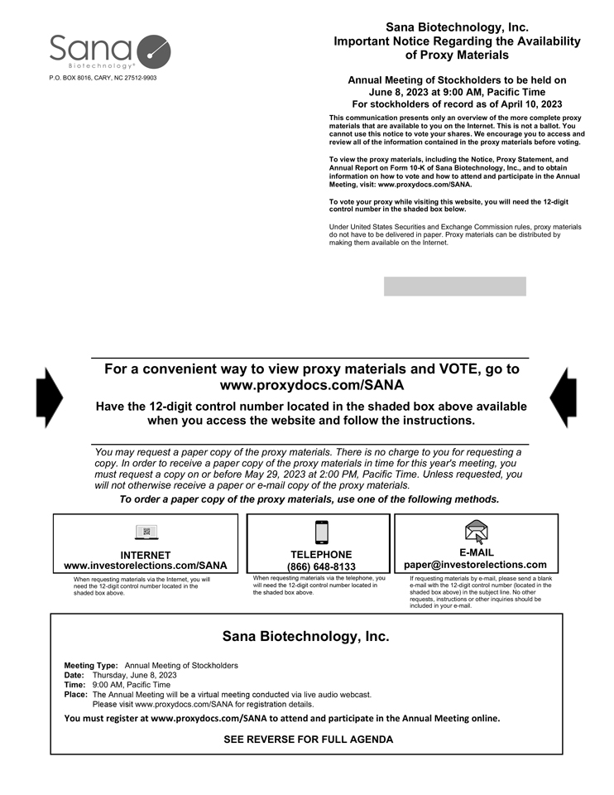
P.O. BOX 8016, CARY, NC 27512-9903 Sana Biotechnology, Inc. Important Notice Regarding the Availability of Proxy Materials Annual Meeting of Stockholders to be held on June 8, 2023 at 9:00 AM, Pacific Time For stockholders of record as of April 10, 2023 This communication presents only an overview of the more complete proxy materials that are available to you on the Internet. This is not a ballot. You cannot use this notice to vote your shares. We encourage you to access and review all of the information contained in the proxy materials before voting. To view the proxy materials, including the Notice, Proxy Statement, and Annual Report on Form 10-K of Sana Biotechnology, Inc., and to obtain information on how to vote and how to attend and participate in the Annual Meeting, visit: www.proxydocs.com/SANA. To vote your proxy while visiting this website, you will need the 12-digit control number in the shaded box below. Under United States Securities and Exchange Commission rules, proxy materials do not have to be delivered in paper. Proxy materials can be distributed by making them available on the Internet. For a convenient way to view proxy materials and VOTE, go to www.proxydocs.com/SANA Have the 12-digit control number located in the shaded box above available when you access the website and follow the instructions. You may request a paper copy of the proxy materials. There is no charge to you for requesting a copy. In order to receive a paper copy of the proxy materials in time for this years meeting, you must request a copy on or before May 29, 2023 at 2:00 PM, Pacific Time. Unless requested, you will not otherwise receive a paper or e-mail copy of the proxy materials. To order a paper copy of the proxy materials, use one of the following methods. INTERNET www.investorelections.com/SANA When requesting materials via the Internet, you will need the 12-digit control number located in the shaded box above. TELEPHONE (866) 648-8133 When requesting materials via the telephone, you will need the 12-digit control number located in the shaded box above. E-MAIL paper@investorelections.com If requesting materials by e-mail, please send a blank e-mail with the 12-digit control number (located in the shaded box above) in the subject line. No other requests, instructions or other inquiries should be included in your e-mail. Sana Biotechnology, Inc. Meeting Type: Annual Meeting of Stockholders Date: Thursday, June 8, 2023 Time: 9:00 AM, Pacific Time Place: The Annual Meeting will be a virtual meeting conducted via live audio webcast. Please visit www.proxydocs.com/SANA for registration details. You must register at www.proxydocs.com/SANA to attend and participate in the Annual Meeting online. SEE REVERSE FOR FULL AGENDA

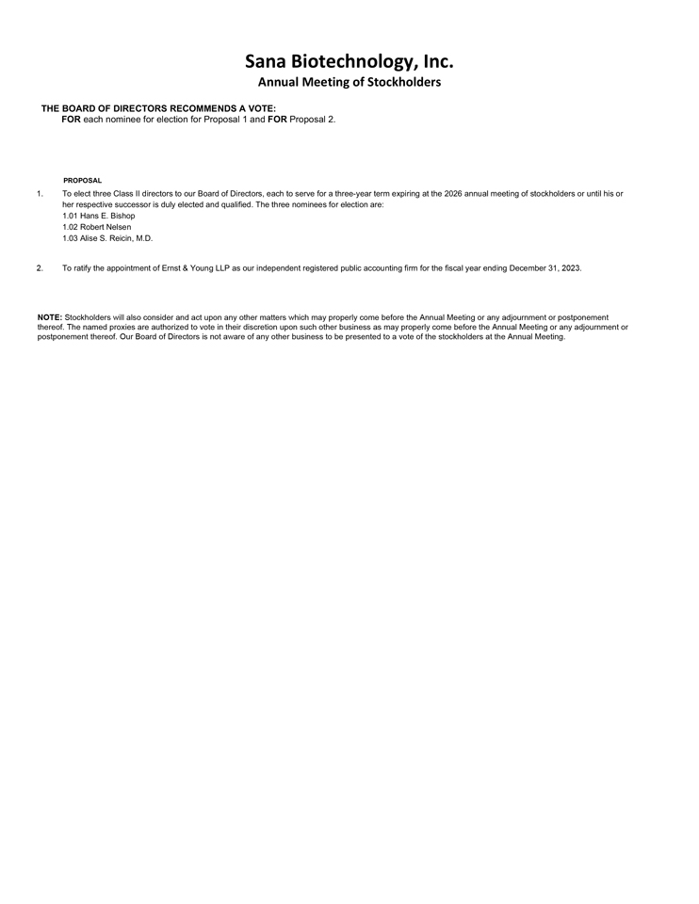
Sana Biotechnology, Inc. Annual Meeting of Stockholders THE BOARD OF DIRECTORS RECOMMENDS A VOTE: FOR each nominee for election for Proposal 1 and FOR Proposal 2. PROPOSAL 1. To elect three Class II directors to our Board of Directors, each to serve for a three-year term expiring at the 2026 annual meeting of stockholders or until his or her respective successor is duly elected and qualified. The three nominees for election are: 1.01 Hans E. Bishop 1.02 Robert Nelsen 1.03 Alise S. Reicin, M.D. 2. To ratify the appointment of Ernst & Young LLP as our independent registered public accounting firm for the fiscal year ending December 31, 2023. NOTE: Stockholders will also consider and act upon any other matters which may properly come before the Annual Meeting or any adjournment or postponement thereof. The named proxies are authorized to vote in their discretion upon such other business as may properly come before the Annual Meeting or any adjournment or postponement thereof. Our Board of Directors is not aware of any other business to be presented to a vote of the stockholders at the Annual Meeting.

